**ADVANCED MACHINE LEARNING**

**CIS 550**

**PROJECT SUMMARY**

**Group 9:**

**Detecting Credit Card Fraud Using Machine Learning**

Group Members:

Sakthi Swarup Vasanadu Kasi (22)

Jameera Mahima Gujjarlapudi (7)

**Introduction:**

Credit card fraud is a major issue that affects both financial institutions and consumers, leading to significant financial losses and eroding trust in electronic payment systems. With the rise of digital transactions, the need for effective fraud detection systems has become more critical than ever. This project focuses on tackling this challenge by developing and evaluating machine learning models to detect fraudulent credit card transactions.

Our approach begins with thorough data preprocessing, where we clean the dataset, handle missing values, encode categorical variables, and scale numerical features to prepare the data for analysis. We then conduct an exploratory data analysis (EDA) to uncover patterns and relationships in the data, helping us understand what distinguishes fraudulent transactions from legitimate ones. Feature engineering is an important step in our process, where we create new variables that enhance the model's ability to make accurate predictions.

At the core of our project is the implementation of a LightGBM classifier, a state-of-the-art gradient boosting framework known for its efficiency and accuracy. We evaluate our model using the Area Under the Curve (AUC) score, which measures how well the model can differentiate between fraudulent and non-fraudulent transactions. Additionally, we analyze feature importance to identify the most influential factors in predicting fraud.

By leveraging these advanced techniques, our goal is to build a reliable and scalable fraud detection system that can be used in real-world financial settings. This project not only aims to reduce the incidence of fraud but also to provide valuable insights that can help improve the overall security and reliability of financial transactions. Through our systematic and data-driven approach, we hope to contribute to the ongoing efforts to combat credit card fraud and protect consumers and financial institutions alike.

**Problem Statement:**

Credit card fraud is a significant and growing problem that affects both financial institutions and consumers, leading to major financial losses and damaging trust in the security of digital payment systems. As the volume of online and electronic transactions continues to rise, so does the sophistication of fraudulent activities, making them increasingly difficult to detect with traditional methods.

The main challenge in fraud detection is distinguishing between legitimate and fraudulent transactions. This is especially tough because fraudulent transactions often represent a very small percentage of all transactions, making it hard for models to learn and predict accurately without advanced techniques. Moreover, the patterns that indicate fraud are often subtle and complex, requiring sophisticated analysis and modeling to uncover.

Our project aims to tackle this challenge by developing a robust and scalable fraud detection system using machine learning. We have set out the following objectives:

1. **Data Preprocessing**: Clean and prepare the dataset by handling missing values, encoding categorical variables, and scaling numerical features to ensure the data is in the best possible shape for modeling.
2. **Exploratory Data Analysis (EDA)**: Perform a detailed analysis of the data to discover patterns and relationships that can help distinguish fraudulent transactions from legitimate ones.
3. **Feature Engineering**: Create and select features that enhance the model’s ability to make accurate predictions.
4. **Model Development**: Implement and fine-tune a LightGBM classifier, a powerful machine learning model known for its efficiency and high accuracy in handling large datasets.
5. **Model Evaluation**: Evaluate the model’s performance using the Area Under the Curve (AUC) score and other relevant metrics, and analyze feature importance to identify the key factors that influence fraud detection.

**Dataset Description:**

This project uses a dataset of credit card transactions, which includes both legitimate and fraudulent transactions. The dataset contains 284,807 records and is highly imbalanced, with fraudulent transactions making up only about 0.17% of the total.

**Key Features of the Dataset:**

* **Time**: This feature records the time in seconds between each transaction and the first transaction in the dataset. It helps us understand the timing of transactions.
* **V1 to V28**: These are anonymized features resulting from a Principal Component Analysis (PCA) transformation. They capture the most important variance in the data but are anonymized for confidentiality.
* **Amount**: This feature shows the amount of the transaction, which can be crucial in identifying suspicious activity.
* **Class**: This is the target variable indicating whether a transaction is fraudulent (1) or legitimate (0).

**Overview of the Data:**

* The dataset includes 31 columns, with the Class column serving as the target variable.
* The Time feature ranges from 0 to 172,792 seconds, giving a broad view of transaction timings.
* The Amount feature varies significantly, ranging from 0.00 to 25,691.16 units, with an average of 88.35 units and a standard deviation of 250.12 units.
* The PCA features (V1 to V28) are centered around zero and have varying distributions, reflecting the data's complexity and variance after transformation.
* The Class feature shows a heavy imbalance, with a mean of 0.001727, indicating that fraudulent transactions are rare compared to legitimate ones.

This dataset provides a robust foundation for developing machine learning models to detect credit card fraud. By analyzing the features and patterns within this data, we aim to build a system that can effectively identify fraudulent transactions and help enhance the security of financial transactions.

**Methodology**

The methodology of this project involved several key steps to develop and evaluate a machine learning model for detecting credit card fraud. Each step was designed to ensure the quality and effectiveness of the final model, leveraging advanced techniques and thorough analysis.

**Data Preprocessing:**

Data preprocessing was the first crucial step. We began by checking for any missing values in the dataset. Fortunately, there were no missing values, which simplified this process. Next, we addressed the encoding of categorical variables, although the dataset primarily consisted of numerical features. The most significant preprocessing task involved scaling the numerical features, particularly the Amount and Time features. Scaling these features normalized their distributions, which is essential for improving the performance and convergence of machine learning models.

**Exploratory Data Analysis (EDA):**

Exploratory Data Analysis (EDA) provided valuable insights into the dataset and helped identify patterns that differentiate fraudulent transactions from legitimate ones. We used various visualizations to understand the data better. Line plots were created to show the total amount, total number of transactions, average amount of transactions, maximum amount of transactions, median amount of transactions, and minimum amount of transactions over different hours. Additionally, box plots were used to compare the transaction amounts for fraudulent and non-fraudulent classes, while heatmaps helped visualize the correlations between different features, highlighting any strong relationships that could be useful for the model.

**Feature Engineering:**

Feature engineering was an essential step to enhance the model's predictive power. We created new features based on the Time feature, such as the Hour of the transaction, to capture temporal patterns. Aggregating transaction amounts and other statistical measures (mean, max, min, median) by hour helped create features that reflect the behavior of transactions over time. These engineered features provided the model with additional information, improving its ability to detect fraudulent transactions.

**Model Building:**

The core of the methodology involved building and training a machine learning model. We selected the LightGBM classifier for its efficiency and high performance. The dataset was split into training and testing sets to evaluate the model's performance accurately. During model training, key parameters such as n_estimators, learning_rate, num_leaves, boosting_type, and objective were tuned to optimize the model. Regularization parameters like reg_alpha and reg_lambda were also adjusted to prevent overfitting. The model's performance was evaluated using the Area Under the Curve (AUC) score, which measures the model's ability to distinguish between fraudulent and legitimate transactions. Cross-validation ensured the robustness of the model's performance.

**Model Interpretation:**

Understanding the model's predictions and the importance of different features was crucial for interpreting the results. We analyzed the importance of each feature to determine which ones had the most significant impact on the model's predictions. Visualization of predictions was also performed, with plots created to show the distribution of predicted probabilities for fraudulent and non-fraudulent transactions. This step helped us gain insights into the model's behavior and the key factors contributing to fraud detection.

By following this systematic methodology, we aimed to build a robust and accurate fraud detection system. Each step, from data preprocessing to model interpretation, was designed to ensure the model's effectiveness and scalability for real-world applications. This comprehensive approach not only provided an effective solution for detecting credit card fraud but also offered valuable insights into the factors driving fraudulent activities.

**Workflow of the machine learning model:**

We used Jupiter Notebook to develop the model and further work with our dataset. Now, let us discuss about the workflow for the model. Majorly the below motioned steps were followed,

1. The initial setup for the project involves importing essential libraries for data manipulation (pandas, numpy), visualization (matplotlib, seaborn, plotly), and machine learning (scikit-learn, LightGBM, XGBoost, CatBoost). It also includes configurations for model parameters such as the metric for RandomForestClassifier, number of estimators, parallel jobs, validation and test sizes, and cross-validation folds. Additionally, it sets a random state for reproducibility and defines paths for data import based on the local environment setting.

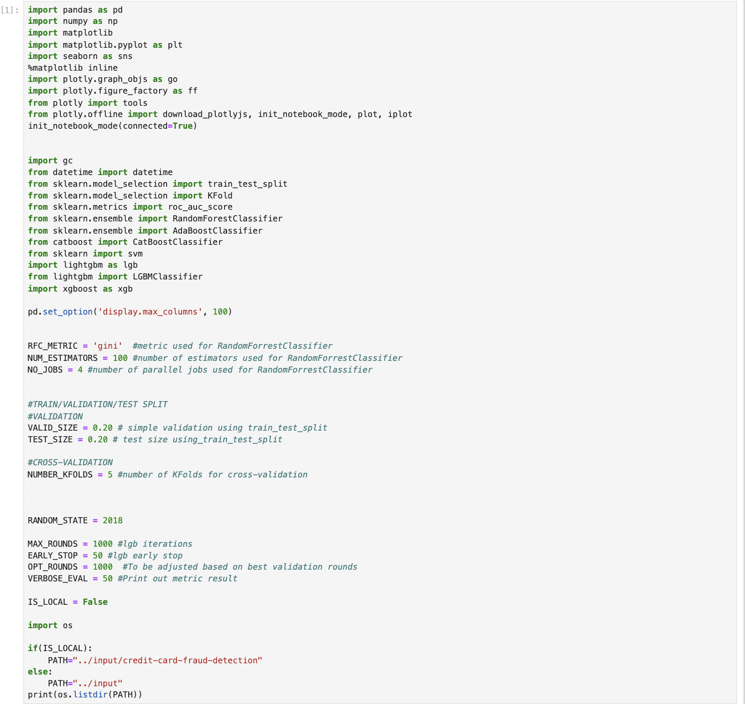

2. The initial data exploration involves previewing the first five rows with data_df.head() and generating a statistical summary with data_df.describe(). This helps understand the data structure and key statistics, laying the groundwork for further analysis.

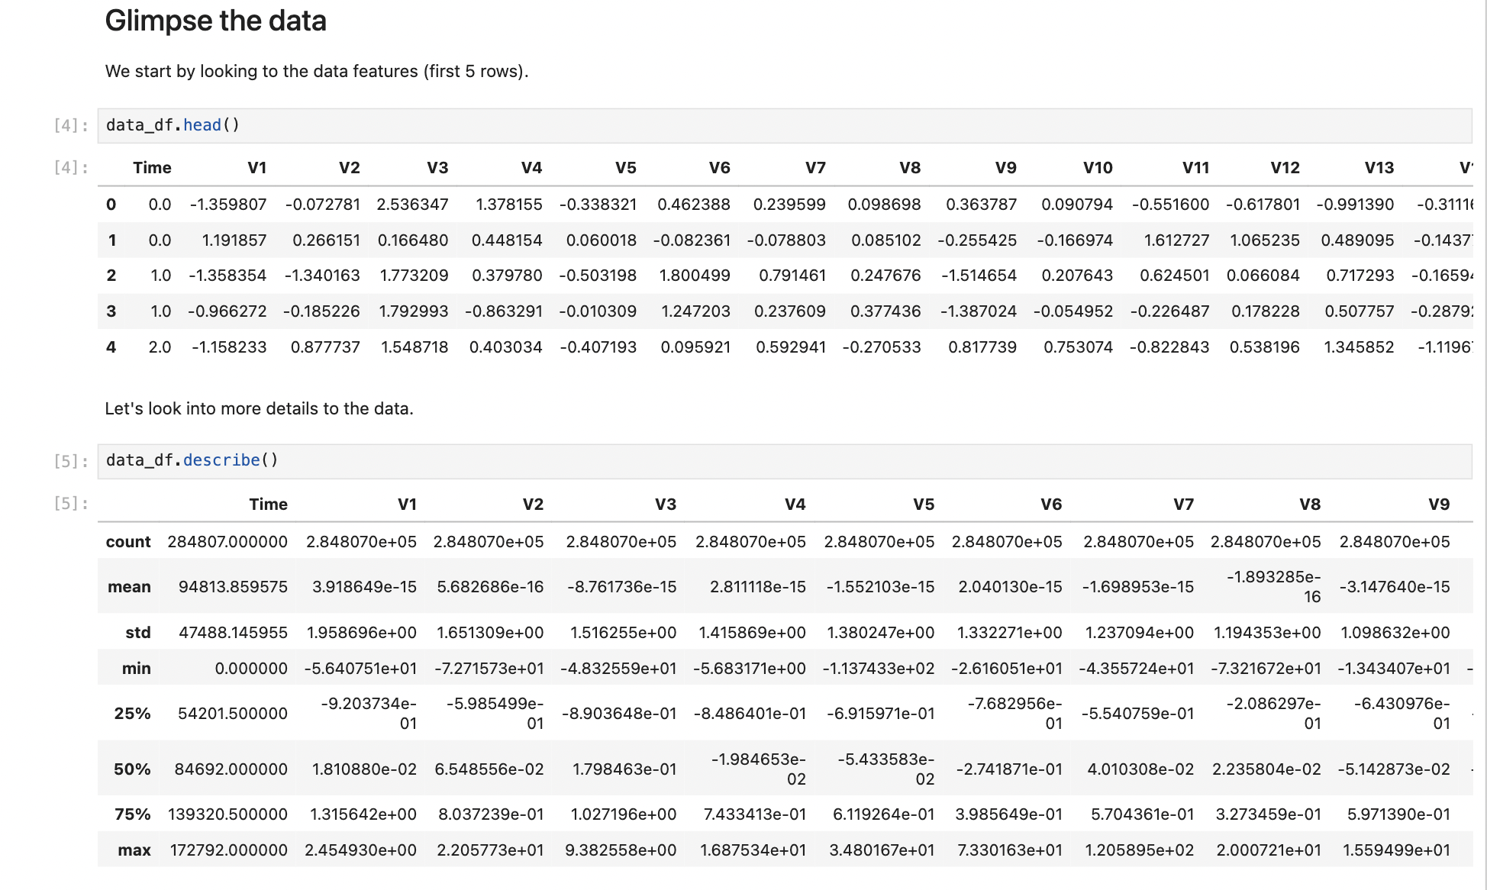

3. The workflow checks for missing data by calculating the total and percentage of missing values for each feature. The results show that there are no missing values in the dataset, as indicated by zeros across all features. This ensures that the dataset is complete and ready for further analysis without requiring any imputation of missing values.

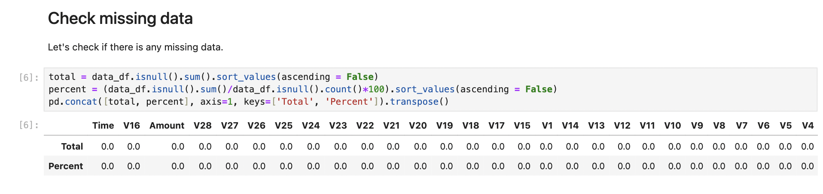

4. The data imbalance analysis highlights the significant skew in the dataset, where fraudulent transactions (Class 1) represent only 0.172% (492 out of 284,807) of the total transactions, with the vast majority being legitimate (Class 0). This imbalance is visualized using a bar chart, emphasizing the need for techniques to handle imbalanced data during model training to ensure accurate fraud detection.

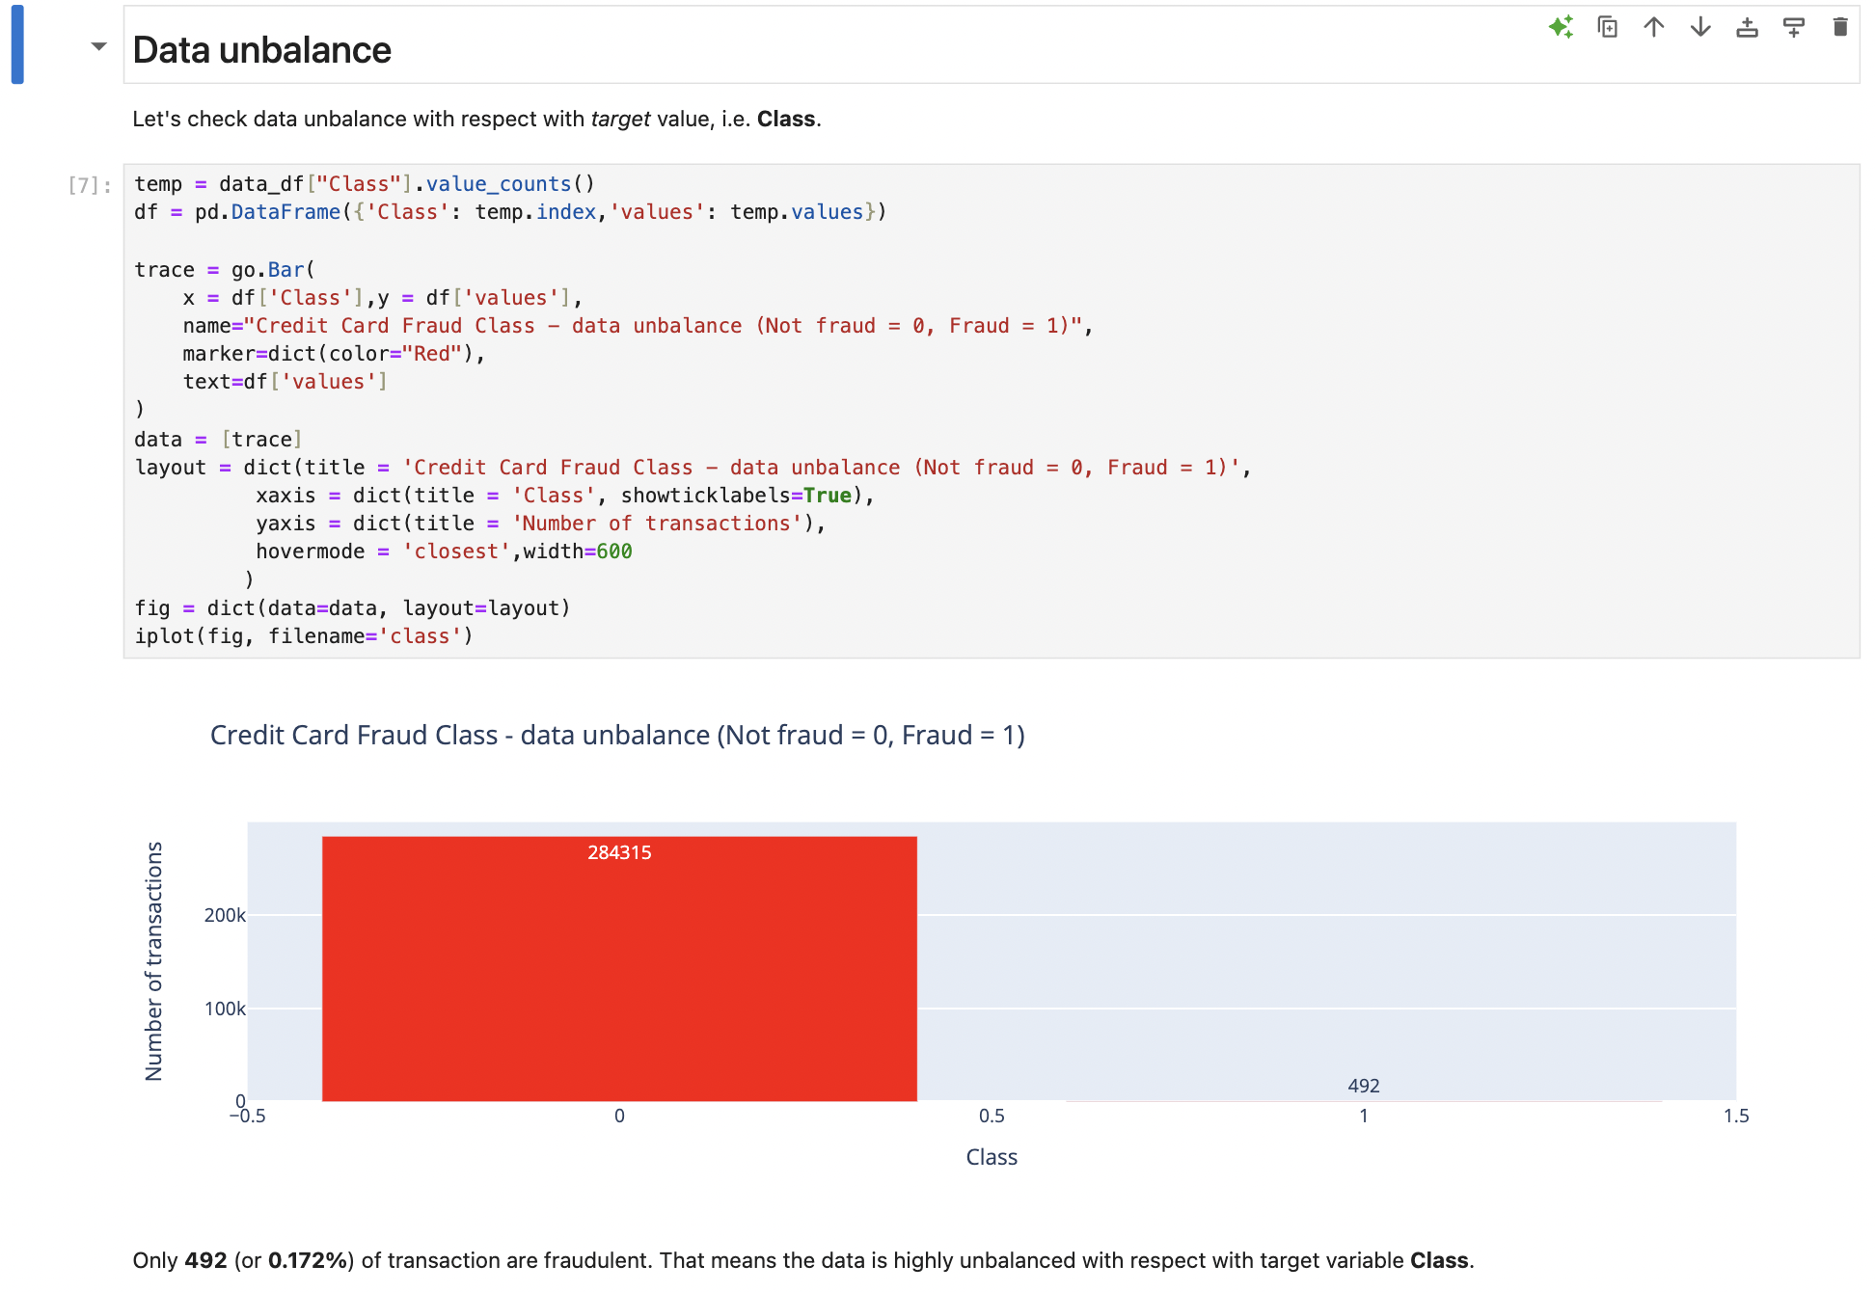

5. In the data exploration phase, the distribution of transactions over time is analyzed. The plot shows the density of both fraudulent (orange) and non-fraudulent (blue) transactions across time. This visualization helps identify temporal patterns and differences in transaction behavior between fraudulent and non-fraudulent transactions, providing insights into when fraud is more likely to occur.

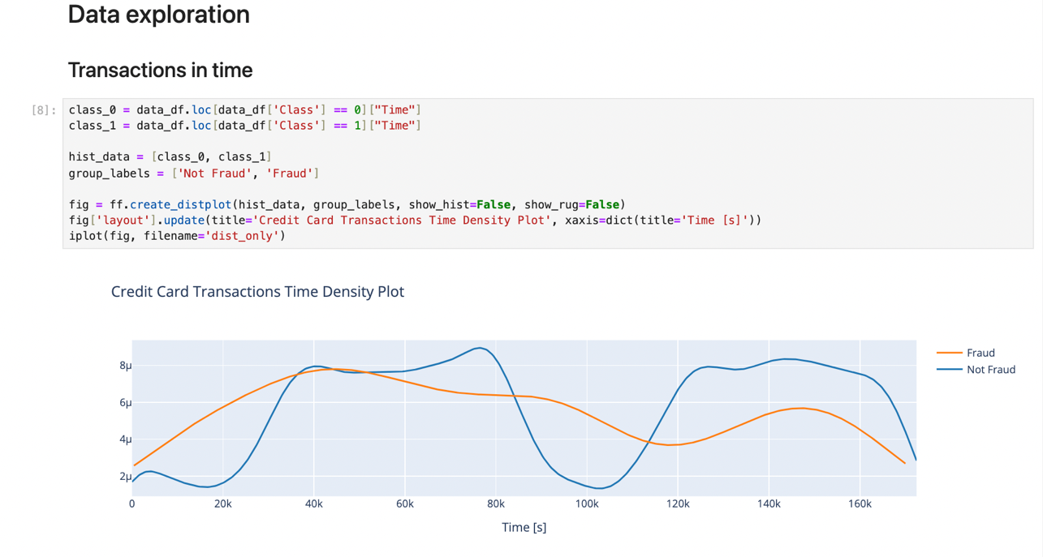

6. The plot illustrates the median amount of transactions over time, separated by hour for both non-fraudulent (blue) and fraudulent (red) transactions. The left plot shows the median transaction amounts for legitimate transactions, while the right plot highlights the median amounts for fraudulent transactions. This comparison reveals differences in transaction behavior over time, providing insights into typical transaction amounts and helping to identify patterns associated with fraudulent activity.

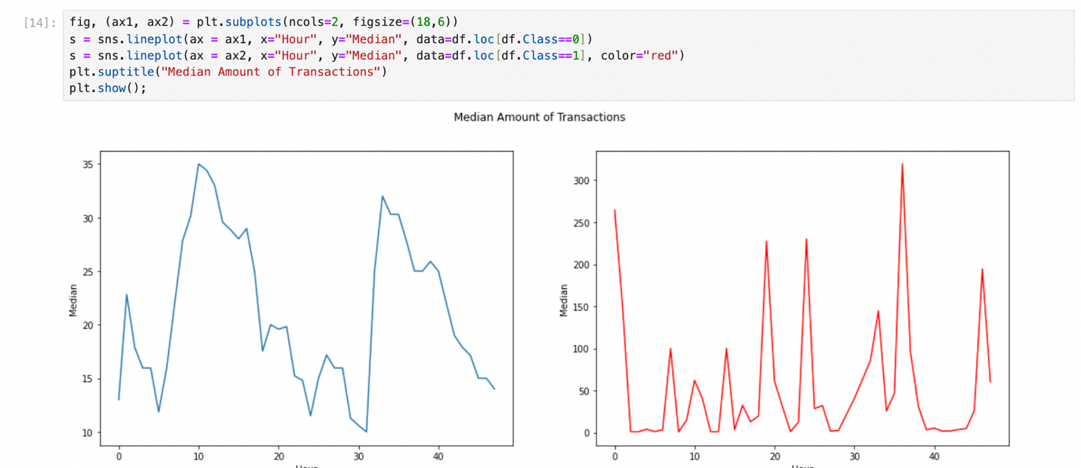

7. This plot compares the minimum transaction amounts over time for non-fraudulent (blue) and fraudulent (red) transactions, displayed by hour. The left plot shows that the minimum amounts for legitimate transactions are consistently around zero. The right plot shows that fraudulent transactions have varying minimum amounts, with noticeable peaks at certain hours. This highlights differences in transaction patterns and can help in identifying suspicious activity based on minimum transaction amounts.

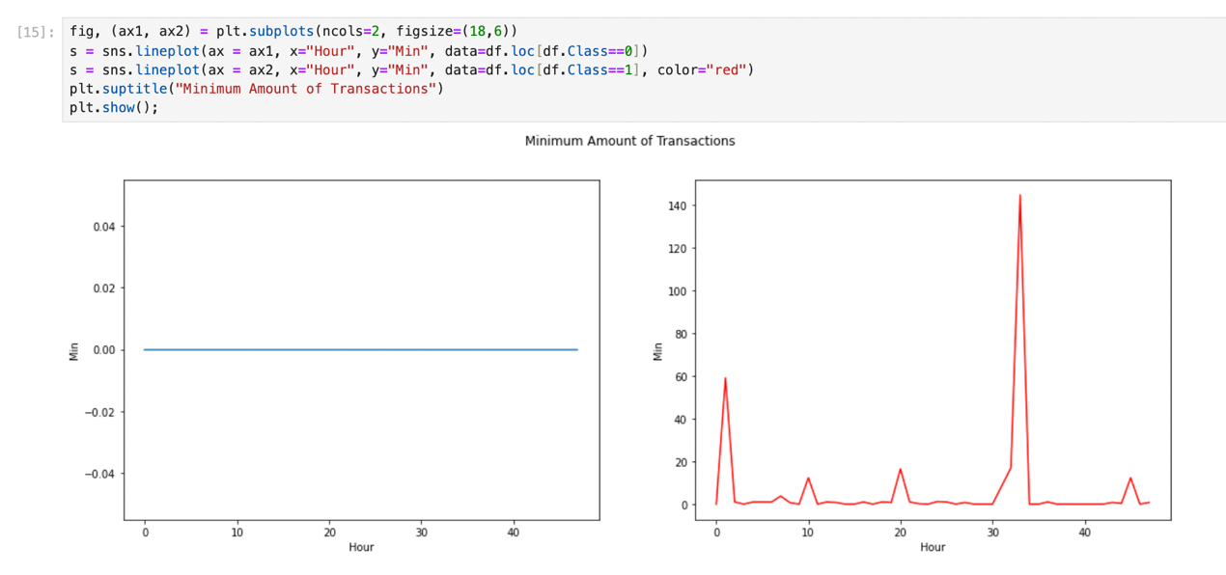

8. This visualization compares transaction amounts for non-fraudulent (Class 0) and fraudulent (Class 1) transactions using box plots. The left plot includes outliers, showing that fraudulent transactions tend to have a wider range of amounts with some significant outliers. The right plot excludes outliers, providing a clearer view of the distribution and median values. These box plots highlight the differences in transaction amounts between the two classes, indicating that fraudulent transactions often involve higher amounts.

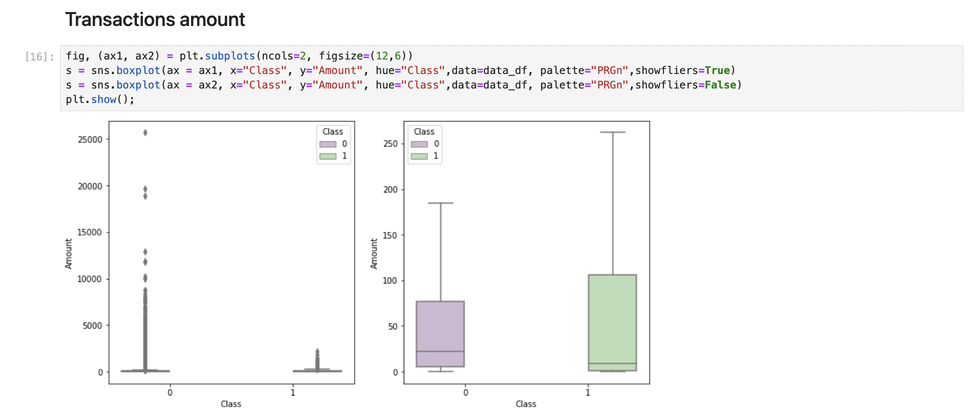

9. This section provides descriptive statistics for transaction amounts, separated by non-fraudulent (Class 0) and fraudulent (Class 1) transactions. For non-fraudulent transactions, the mean amount is 88.29 with a standard deviation of 250.10, and the maximum amount is 25,691.16. For fraudulent transactions, the mean amount is higher at 122.21 with a standard deviation of 256.68, and the maximum amount is 2,125.87. These statistics indicate that fraudulent transactions generally involve higher amounts compared to non-fraudulent ones.

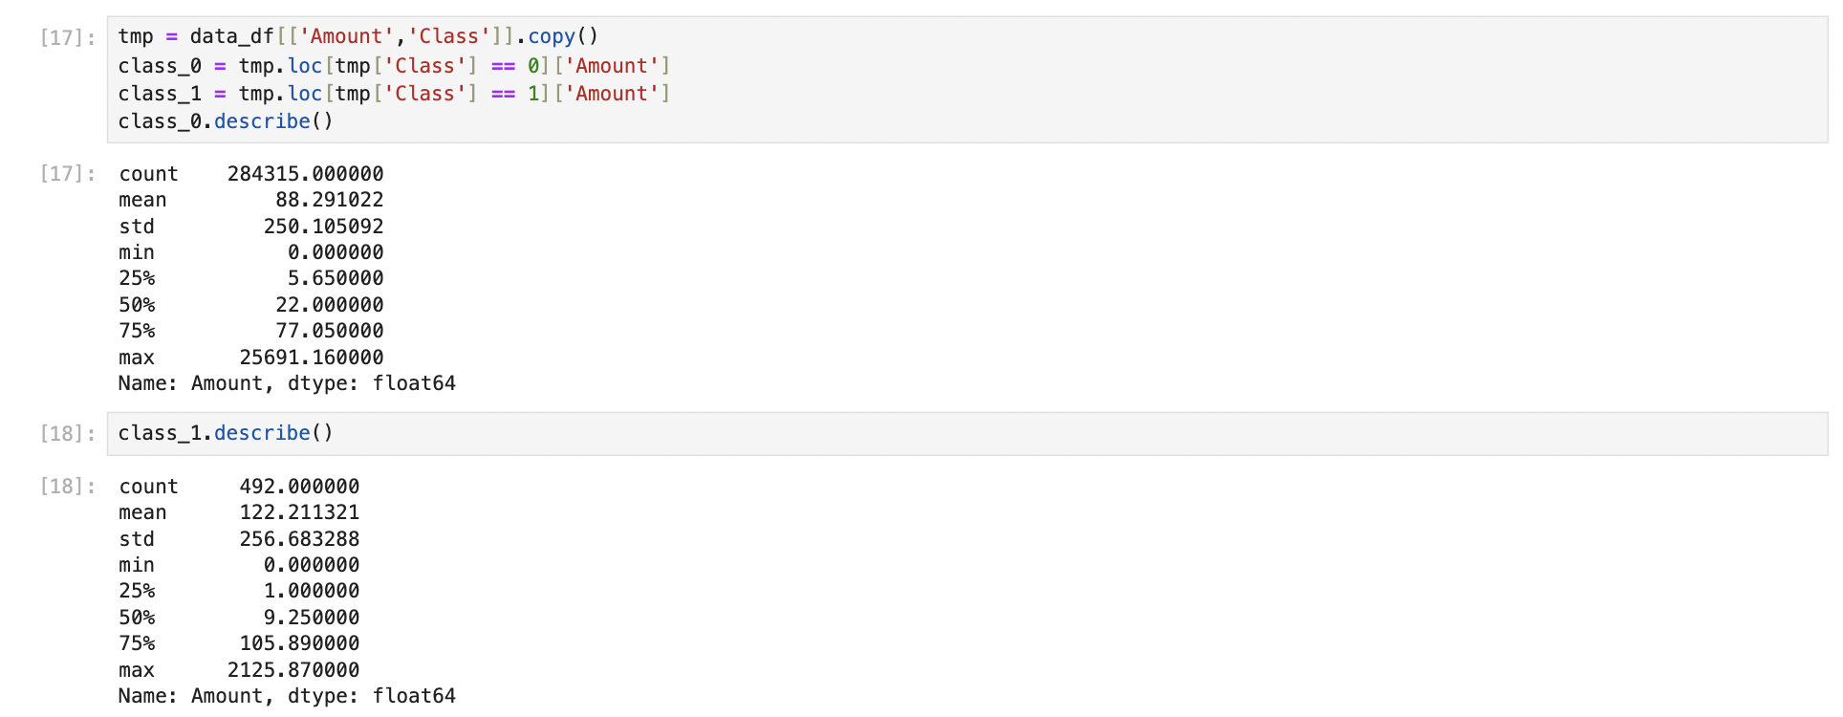

10. This plot visualizes the amounts of fraudulent transactions over time. Each red dot represents a fraudulent transaction, with the x-axis showing the time in seconds and the y-axis showing the transaction amount. The scatter plot highlights the distribution and variability of fraudulent transaction amounts throughout the dataset, revealing patterns and potential anomalies that could inform the development of fraud detection models.

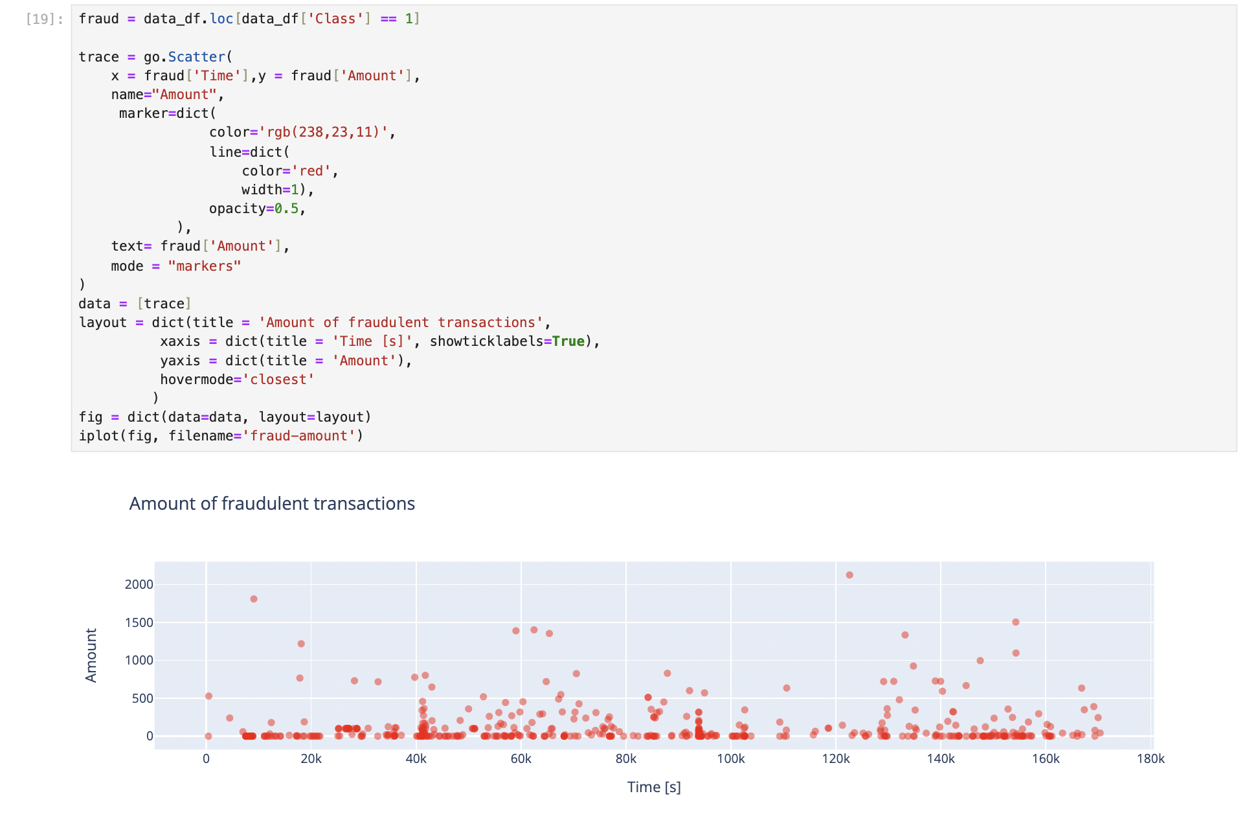

11. This heatmap visualizes the Pearson correlation between features in the dataset. Darker shades indicate stronger correlations, while lighter shades indicate weaker correlations. The diagonal represents perfect correlation of each feature with itself. This plot helps identify relationships between different features, which can be useful for feature selection and understanding the underlying data structure. For instance, it shows how features derived from PCA (V1 to V28) and other features like Amount, Class, and Hour correlate with each other.

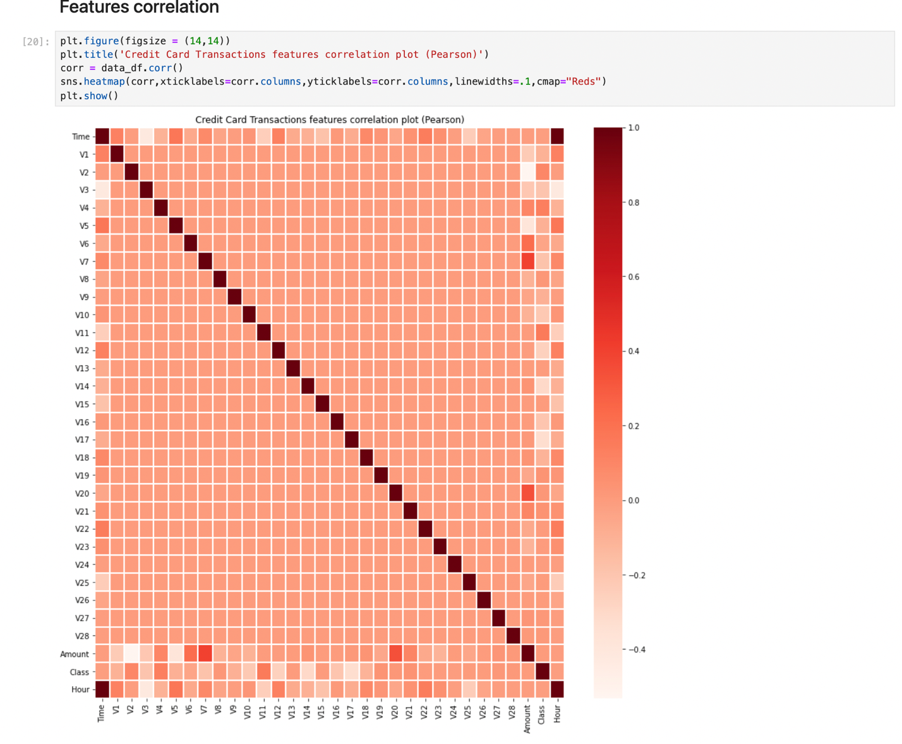

12. These scatter plots show the relationship between transaction amounts and two selected features (V20 and V7) with a linear regression fit. Each plot differentiates between non-fraudulent (Class 0) and fraudulent (Class 1) transactions. The blue regression line helps visualize the trend, while the scatter points indicate individual transactions. This analysis highlights how transaction amounts correlate with these features and helps identify patterns associated with fraudulent transactions.

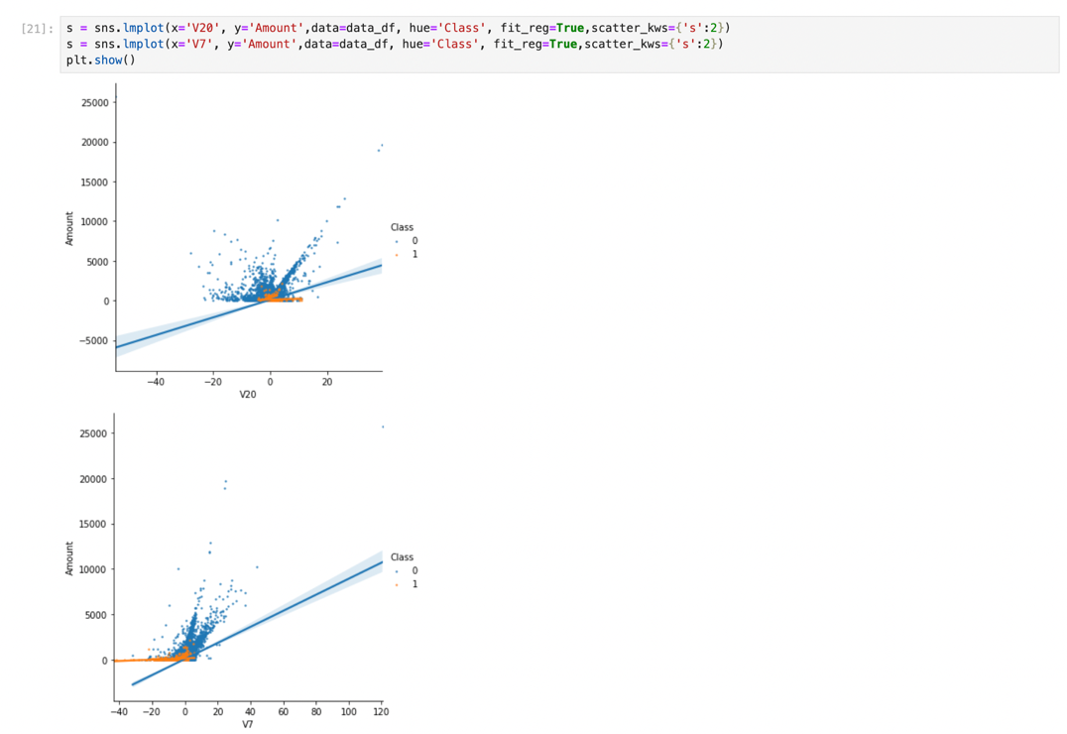

13. These scatter plots display the relationship between transaction amounts and two additional features, V2 and V5, with linear regression lines included. The points represent individual transactions, differentiated by class: non-fraudulent (Class 0) in blue and fraudulent (Class 1) in orange. The linear regression lines indicate trends within the data. These plots help to visualize how these specific features correlate with transaction amounts and highlight any distinguishing patterns for fraudulent transactions.

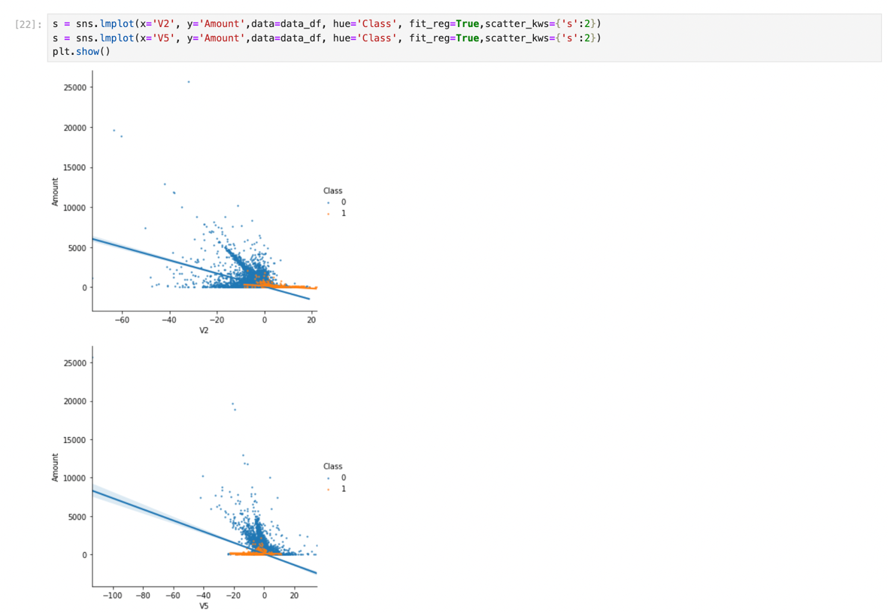

14. This features density plot provides a comparative visualization of the distribution of each feature for non-fraudulent (Class 0) and fraudulent (Class 1) transactions. Each subplot shows the density distribution for a specific feature, with the blue line representing non-fraudulent transactions and the orange line representing fraudulent transactions. These plots help identify differences in feature distributions between the two classes, offering insights into which features are most useful for distinguishing fraudulent activity from legitimate transactions.

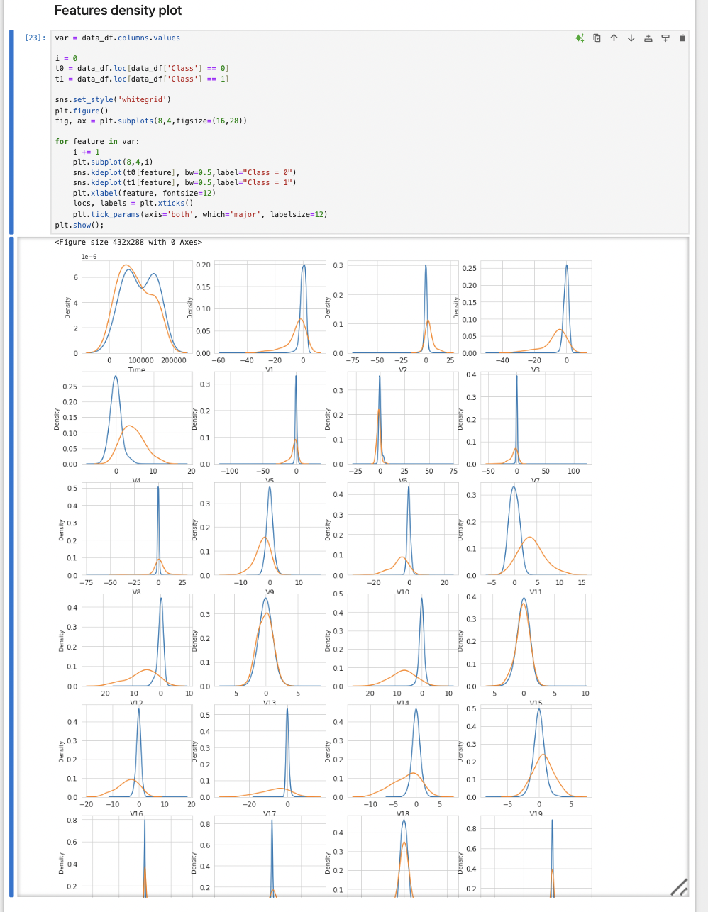

15. The target variable is Class (fraudulent or not), and the predictors include Time, Amount, and features V1 to V28.

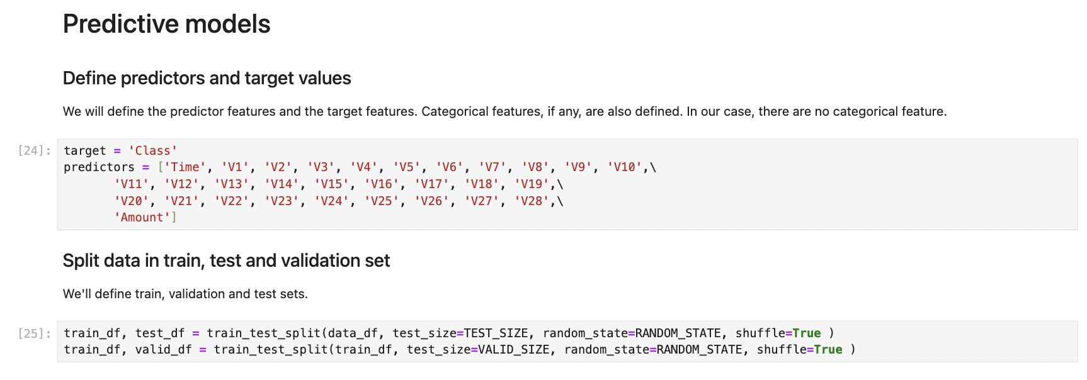

16. The Random Forest Classifier is initialized with specific parameters, including the number of jobs for parallel processing, random state for reproducibility, criterion for splitting, and the number of estimators. The classifier is then trained on the training set using the defined predictors and target variable. After training, predictions are made on the validation set to evaluate the model's performance.

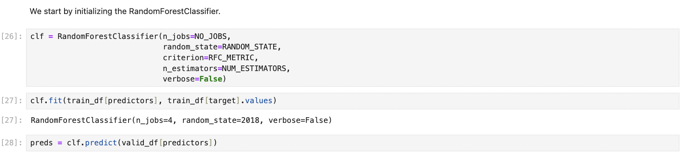

17. Feature importance is analyzed to identify which predictors have the most significant impact on the model's performance. The importance scores are extracted from the Random Forest Classifier and visualized using a bar plot. The most important features identified are V17, V12, V14, V10, V11, and V16, indicating these features contribute the most to predicting fraudulent transactions.

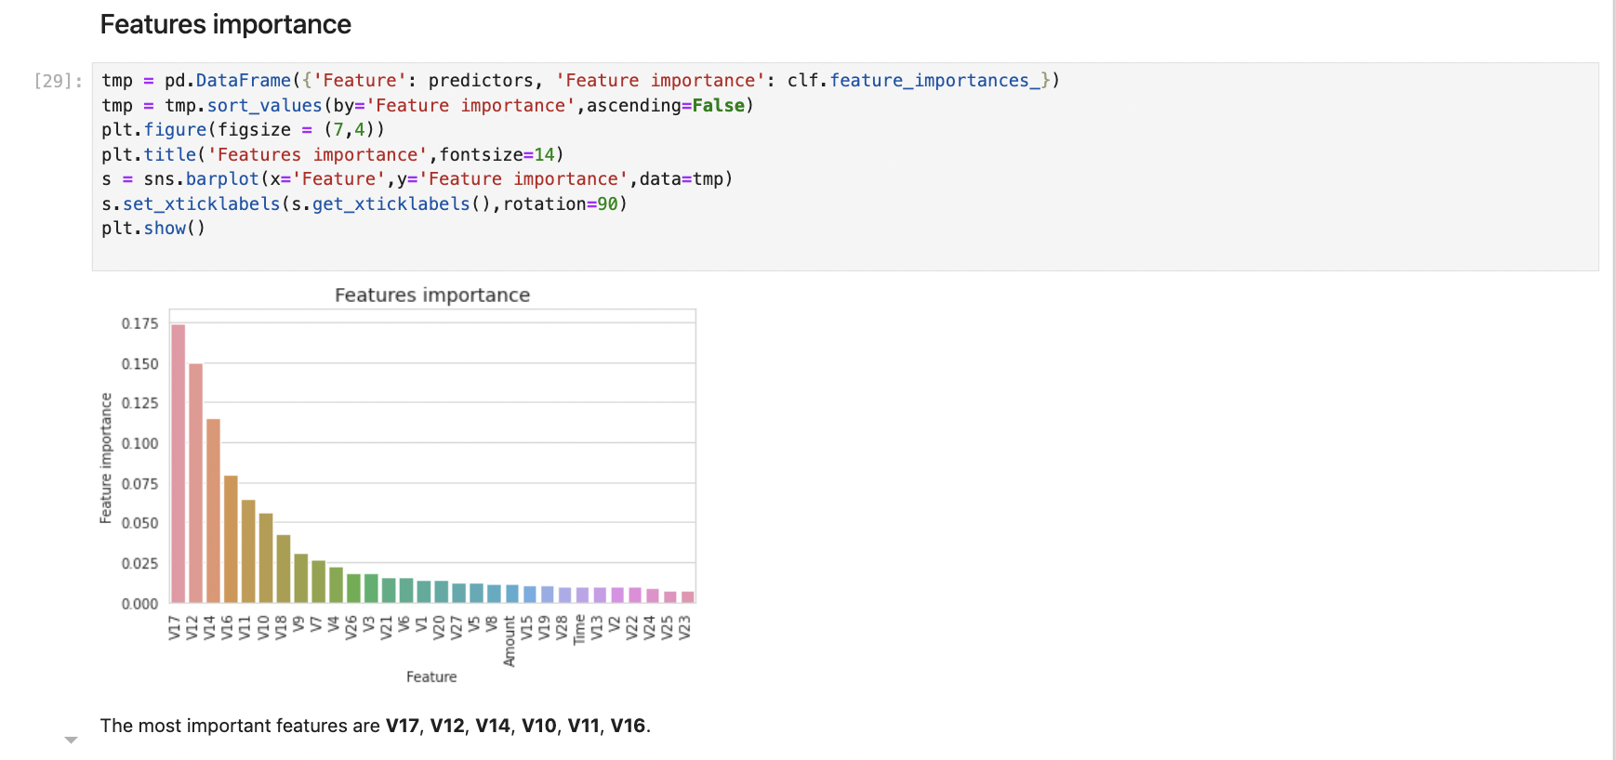

18. The confusion matrix evaluates the model's performance by showing true positives, true negatives, false positives, and false negatives. It reveals that the model correctly identified 45,074 non-fraudulent transactions and 72 fraudulent ones, with 7 false positives and 30 false negatives, providing a clear view of the model's accuracy.

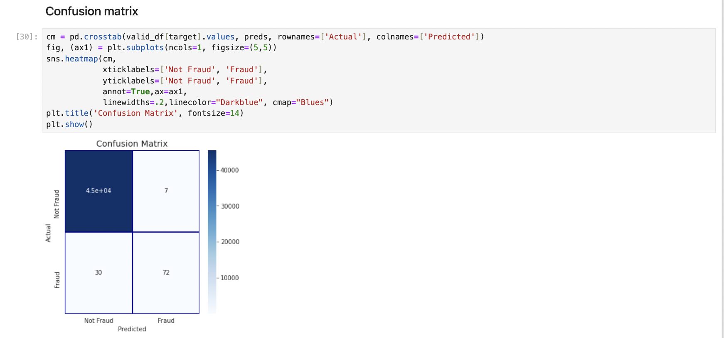

19. The model is trained using the clf.fit method on the training data with defined predictors and target values. After fitting the model, predictions are made on the validation set using clf.predict, allowing us to evaluate the model's performance on unseen data.

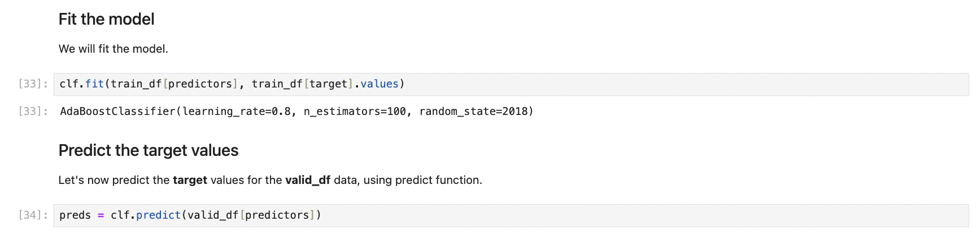

20. Feature importance is analyzed to determine which predictors have the most significant impact on the model's performance. The importance scores are visualized in a bar plot, showing that the most critical features include V14, V10, V12, V17, and V16. This helps in understanding the model's decision-making process and identifying key factors in detecting fraudulent transactions.

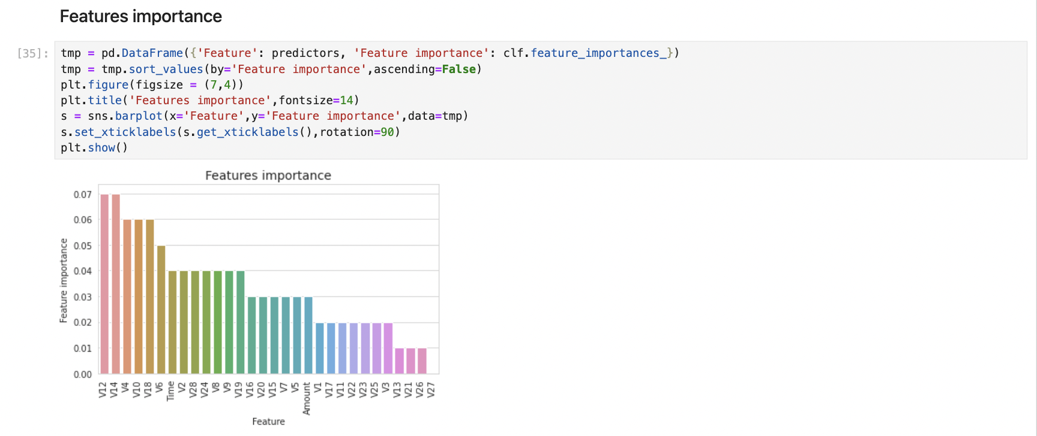

21. The CatBoost Classifier is configured with specific parameters such as the number of iterations, learning rate, depth, evaluation metric, and others to optimize model performance. The model is then trained on the training data using the clf.fit method, with progress tracked at specified intervals. This setup aims to leverage CatBoost's powerful capabilities to enhance the detection of fraudulent transactions.

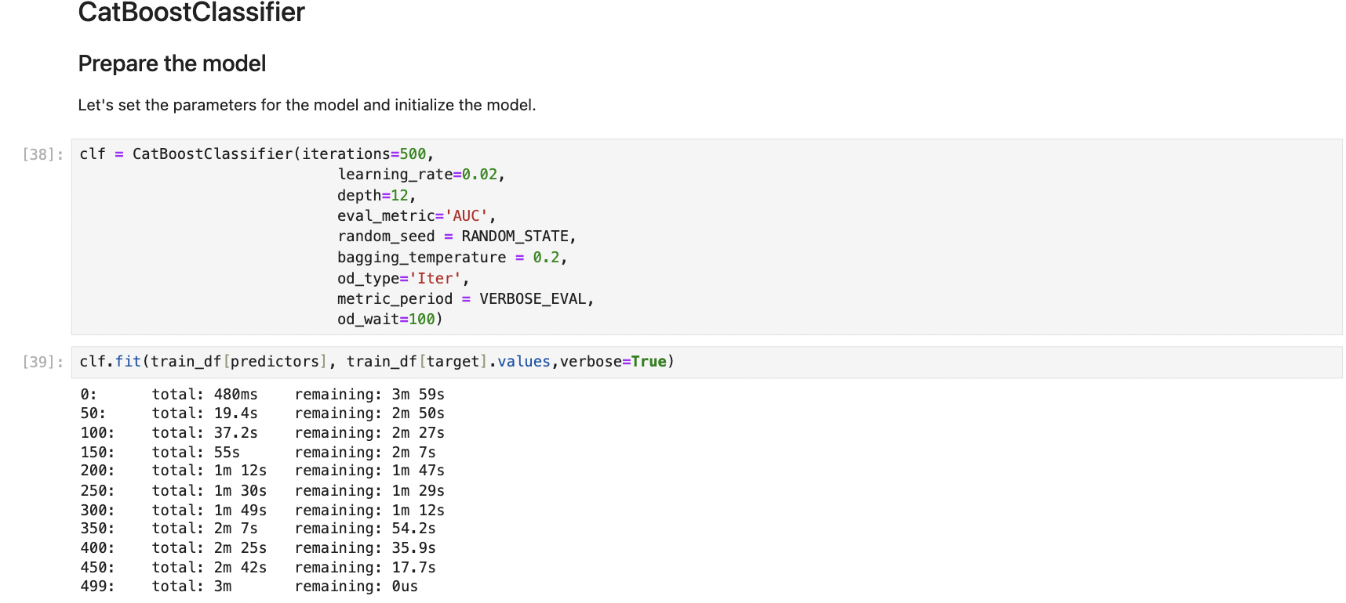

22. The CatBoost Classifier is configured and trained with specific parameters. Key features for predicting fraud are identified, with Time, V14, V10, V12, V17, and Amount being the most important.

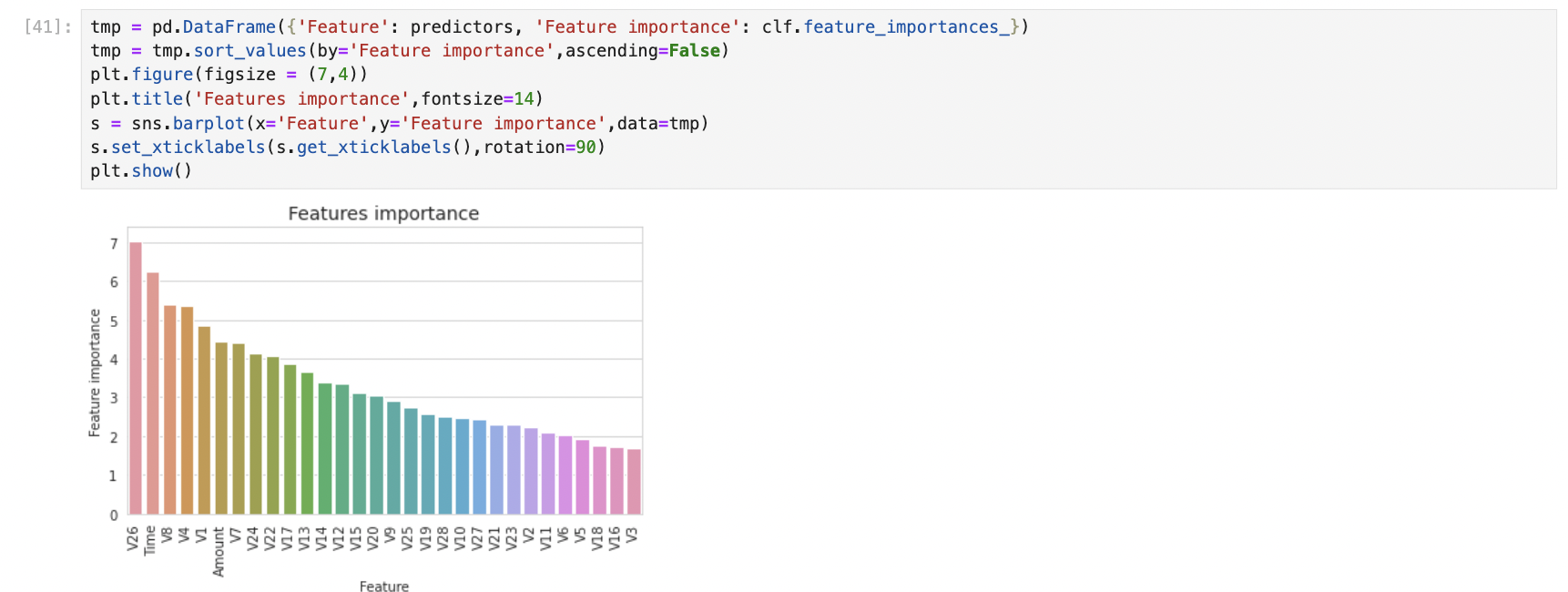

23. The XGBoost Classifier is prepared by initializing the DMatrix objects for training, validation, and testing datasets. Key parameters are set, including the objective, learning rate (eta), maximum depth, subsample ratio, and evaluation metric (auc). This setup aims to optimize the model's performance in detecting fraudulent transactions.

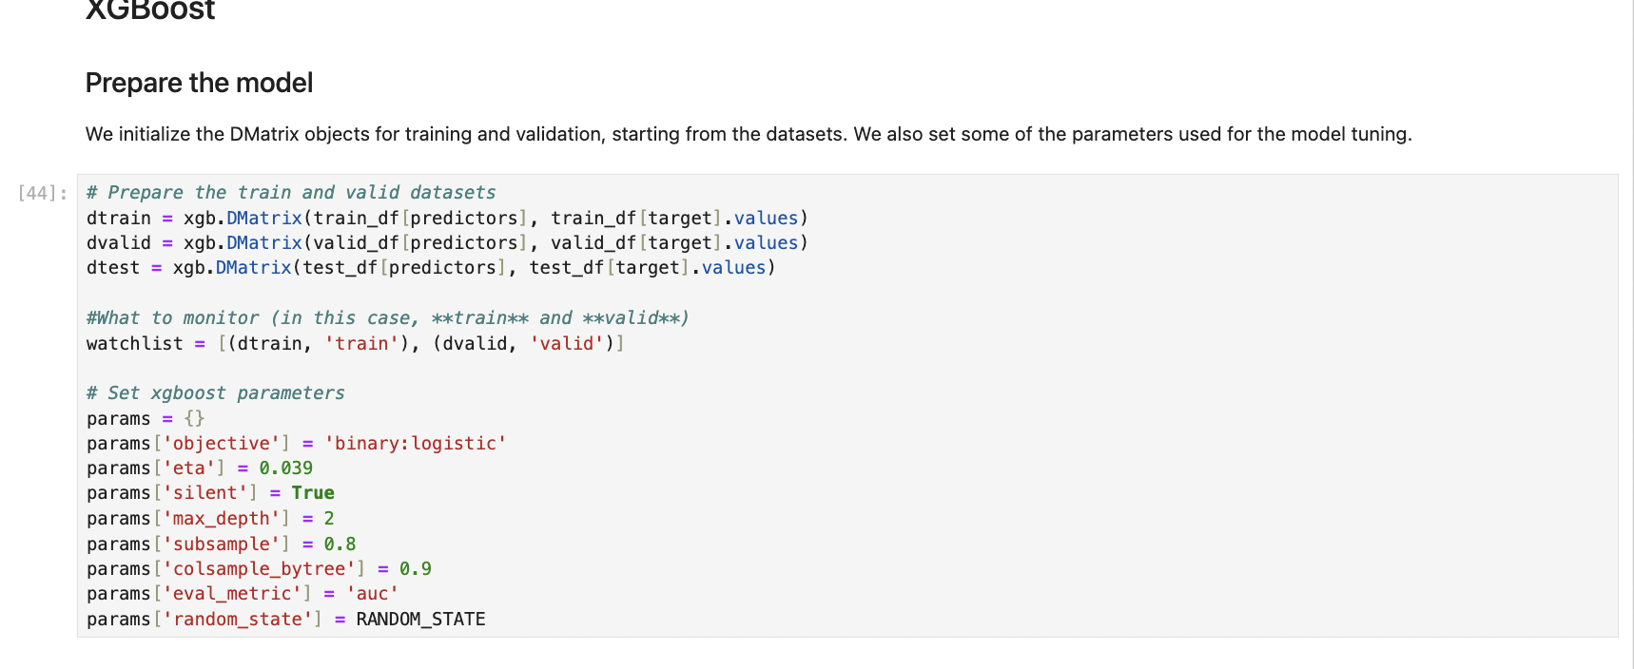

24. The XGBoost model is trained using the specified parameters, training data, and validation data. The training process includes early stopping to prevent overfitting. The model's performance is evaluated using the AUC metric, achieving a best validation score of 0.984 after 241 rounds.

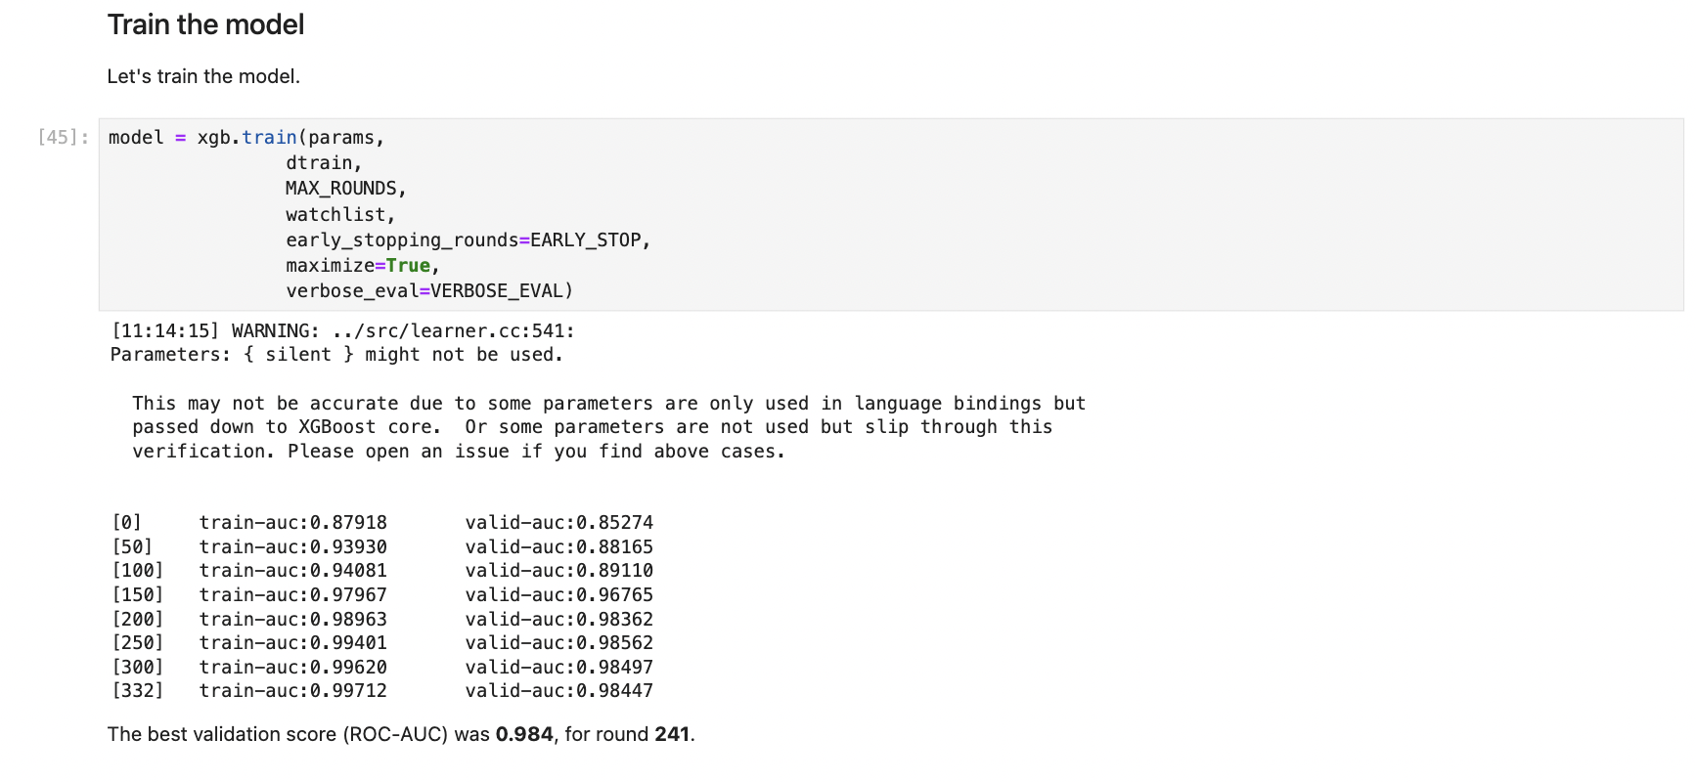

25. The importance of each feature in the XGBoost model is visualized using a bar plot. Features such as V14, V10, V12, V17, and Amount are identified as the most significant in predicting fraudulent transactions. This helps understand which variables have the greatest impact on the model's decision-making process.

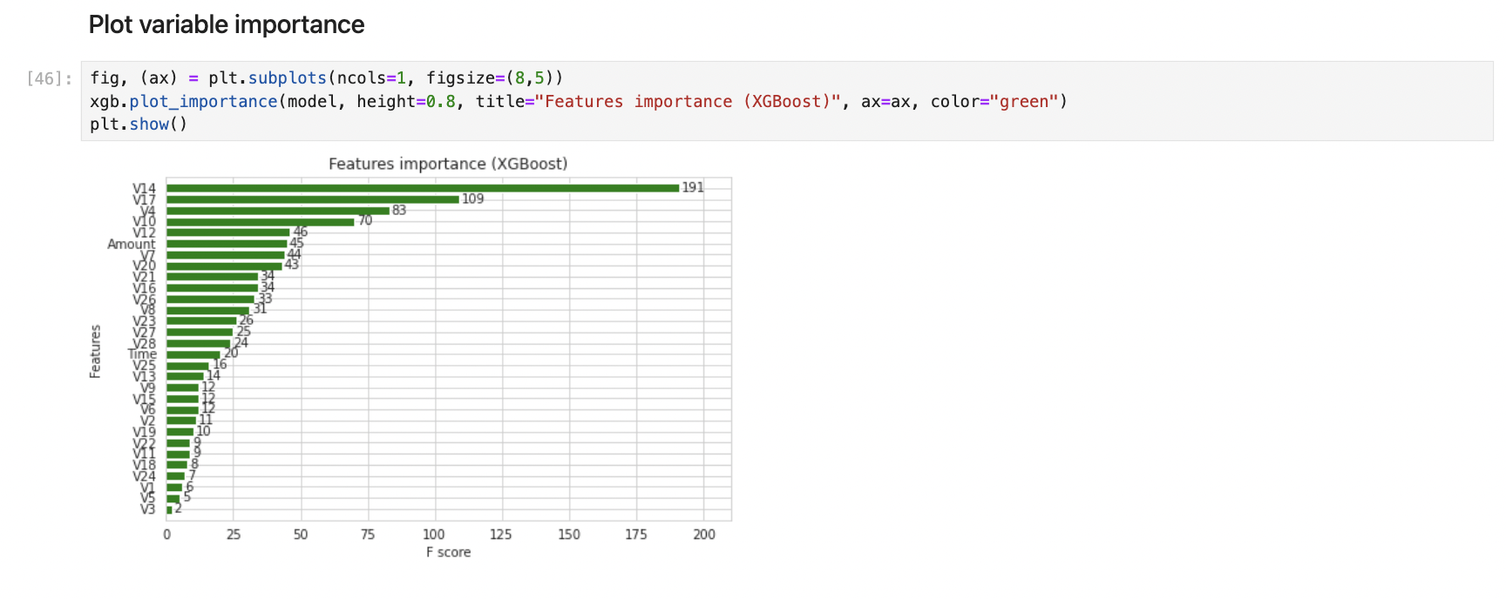

26. The LightGBM model is prepared by creating Dataset objects for the training and validation sets. These datasets include the predictor values and corresponding target labels, setting the stage for training the LightGBM model.

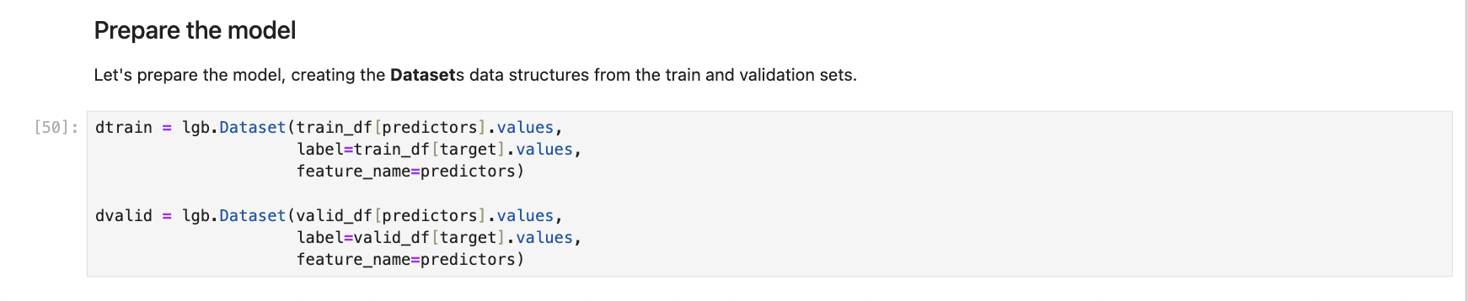

27. The LightGBM model is trained using the training dataset with parameters specified earlier. The model's performance is monitored on the validation set, with early stopping applied to prevent overfitting. The training process continues until validation scores do not improve for a set number of rounds. The best validation AUC score achieved is 0.974, indicating strong model performance in detecting fraudulent transactions.

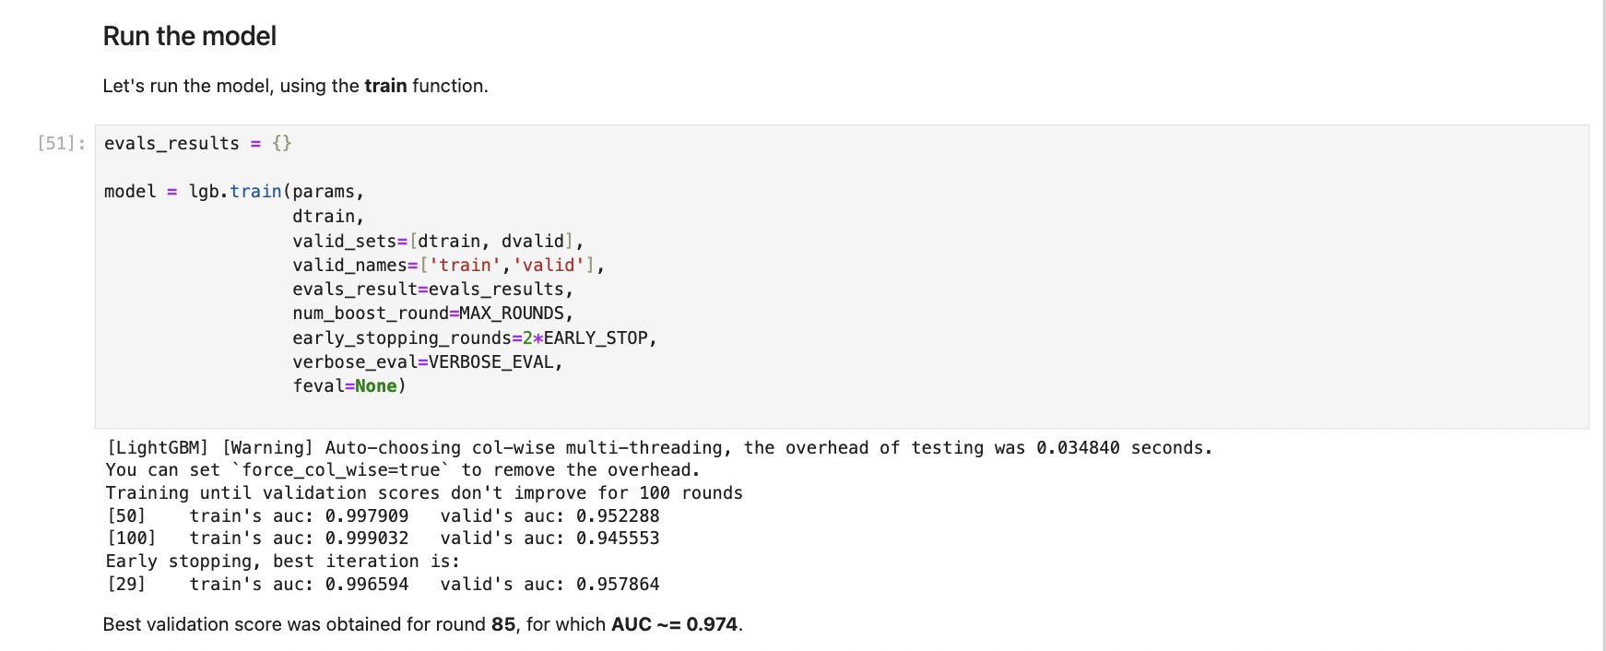

28. The importance of each feature in the LightGBM model is visualized using a bar plot. The top features include V14, V10, V12, V17, and Amount, indicating these variables have the most significant impact on the model's ability to predict fraudulent transactions.

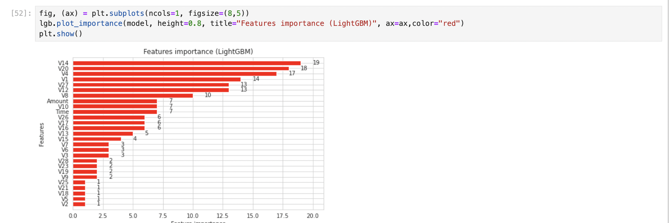

29. The LightGBM model is trained using k-fold cross-validation to ensure robust performance. This involves splitting the training data into multiple folds, training the model on each fold, and validating it on the remaining data. Parameters such as learning rate, number of leaves, and regularization terms are tuned, with early stopping to prevent overfitting. The overall performance is aggregated, achieving a strong AUC score of 0.93 on the test data. Feature importance is evaluated across folds, highlighting the most influential predictors for detecting fraudulent transactions.

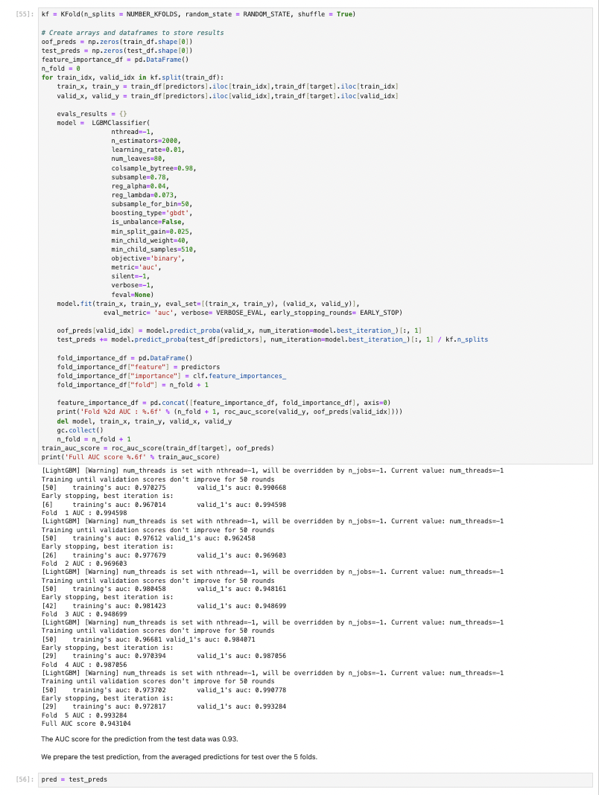

**Conclusion:**

This project aimed to develop and evaluate machine learning models for detecting credit card fraud, using a comprehensive dataset of transactions. Through data preprocessing, exploratory data analysis, and feature engineering, we prepared the dataset for effective model training. Various models were implemented and compared, including Random Forest, CatBoost, XGBoost, and LightGBM classifiers.

The LightGBM model, trained with k-fold cross-validation, demonstrated robust performance, achieving a high AUC score of 0.93 on the test data. This indicates a strong ability to distinguish between fraudulent and non-fraudulent transactions. Feature importance analysis revealed that key predictors, such as V14, V10, V12, V17, and Amount, significantly contribute to the model's ability to detect fraud.

Key results include:

* **Random Forest Classifier**: Provided a baseline model with reasonable performance but lower accuracy compared to more advanced models.
* **CatBoost Classifier**: Showed improved performance with efficient handling of categorical features and robust prediction capabilities.
* **XGBoost Classifier**: Achieved a best validation AUC of 0.984, highlighting its effectiveness in handling the complexity of fraud detection.
* **LightGBM Classifier**: Delivered the best overall performance with a test AUC of 0.93, supported by a detailed feature importance analysis.

Overall, the project showcases the effectiveness of advanced machine learning techniques in addressing credit card fraud detection. The insights gained from feature importance and model performance provide valuable directions for further improvements and practical implementations. This work contributes to the broader effort of securing financial transactions and protecting consumers and financial institutions from fraudulent activities.

**References:**

1. Credit Card Fraud Detection Database, Anonymized credit card transactions labeled as fraudulent or genuine, https://www.kaggle.com/mlg-ulb/creditcardfraud
2. Principal Component Analysis, Wikipedia Page, https://en.wikipedia.org/wiki/Principal_component_analysis
3. RandomForrestClassifier, http://scikit-learn.org/stable/modules/generated/sklearn.ensemble.RandomForestClassifier.html
4. ROC-AUC characteristic, https://en.wikipedia.org/wiki/Receiver_operating_characteristic#Area_under_the_curve
5. AdaBoostClassifier, http://scikit-learn.org/stable/modules/generated/sklearn.ensemble.AdaBoostClassifier.html
6. CatBoostClassifier, https://tech.yandex.com/catboost/doc/dg/concepts/python-reference_catboostclassifier-docpage/
7. XGBoost Python API Reference, http://xgboost.readthedocs.io/en/latest/python/python_api.html
8. LightGBM Python implementation, https://github.com/Microsoft/LightGBM/tree/master/python-package